

POWERD BY ĮEE STORE

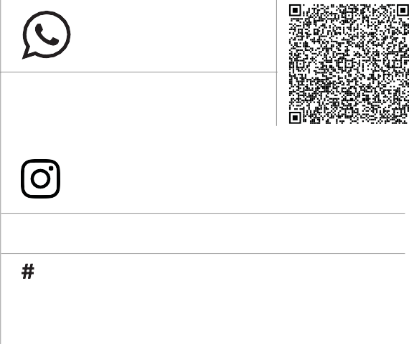

**+91 99945 78802**

**+91 96265 89922**

info@leestoreindia.com www.leestoreindia.com

@leestore_india @pandijegan.k

GSTIN 33DRNPP3773C1ZM

**4765/5, Ayyanarpuram 1st Street, Alangudi Road, Pudukkottai - 622001 Tamilnadu,India.**

|  |  |  |
| --- | --- | --- |
| Invoice No | : | <<billno>> |
| Invoice Date | : | <<billdate>> |

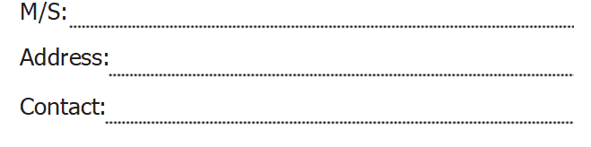

<<custname>>

<<custadd>>

<<custcont>>

<<sgst>>

<<cgst>>

**CGST % SGST %**

<<total>>

<<amt6>>

<<amt5>>

<<up6>>

<<up5>>

<<q5>>

<<sno5>>

<<description5>>

<<amt4>>

<<q4>>

<<up3>>

<<q3>>

<<q2>>

<<sno6>>

<<description6>>

<<description4>>

<<description1>>

<<sno4>>

<<sno3>>

<<sno2>>

<<sno1>>

<<amt3>>

<<amt2>>

<<up4>>

<<up2>>

<<q6>>

<<q1>>

<<up1>>

<<amt1>>

<<description3>>

<<description2>>

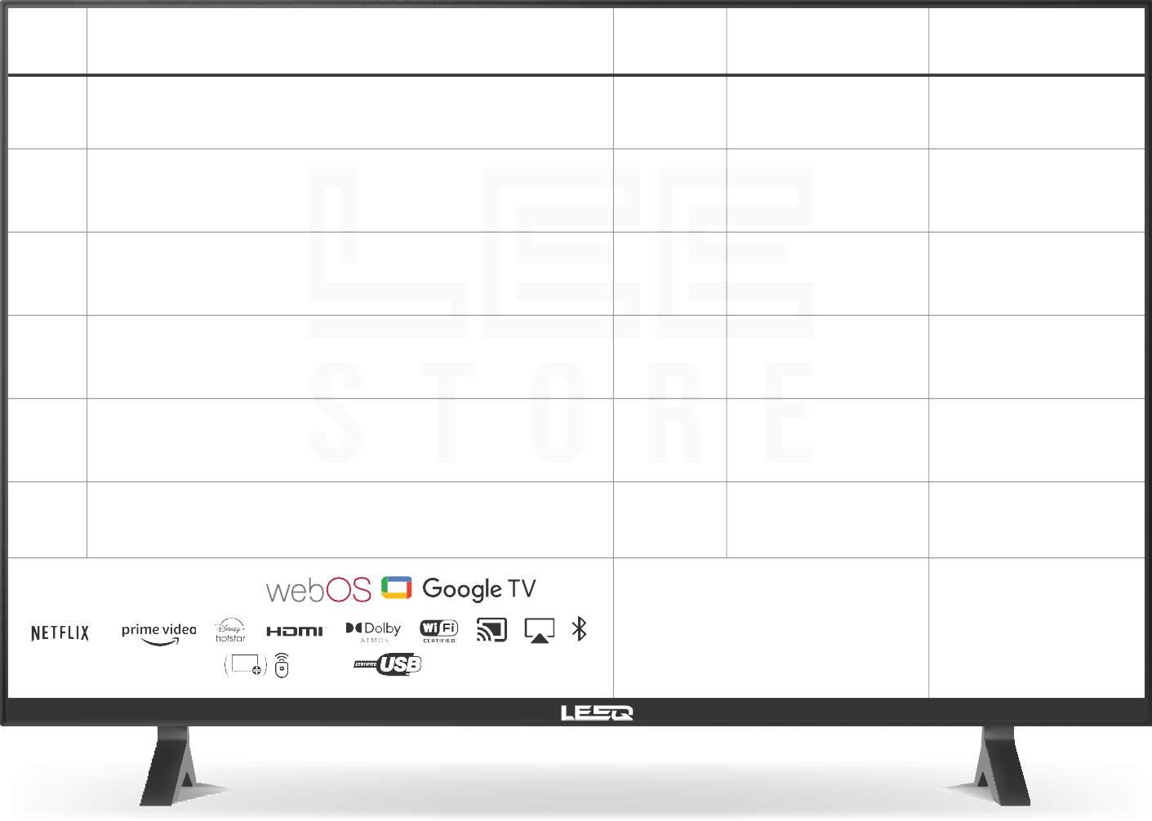

**S.NO**

**DESCRIPTION OF GOODS**

**QTY**

**UNIT PRICE**

**AMOUNT**

**SMART LED TV**

**TOTAL**

magic

Bezel Less

remote

Term & Conditions

Note: Television goods are warranted for a period defined by the

respective manufactures against defect in material & workmanship

Lee Store is given warrant and does hold out warranty of

**LEEQ product sold only.**

**GOODS RECEIVED IN WORKING CONDITION**

SALES PERSON

for LEE STORE





www.leestoreindia.com

Customer Signature Signature